PREMIUM HONG KONG, MACAU, SHENZHEN WITH VENETIAN
0 7 N i g h t s / 0 8 D a ys
D e p a r t u r e D a t e s : OCT 27 , 2019

Hong Kong:  - Hong Kong City Tour  - Victoria Peak on Top  - Aberdeen Harbour  - Repulse Bay  - Jewellery Factory  - Old Clock tower  - One Way Peak Tram Ride  - Madam Tussauds Museum  - Symphony of Light Show  - Avenue of stars (if operative)  - Ocean Park full day trip  - Disney Land full day trip 1 Day 1 Park  - Toy Story Land  - Mystic Point  - Grizzly Gulch  - Main Street USA  - Tomorrow Land  - Fantasy Land  Shenzhen  Shenzhen City Tour:  - Bamboo Factory  - Jade Factory  - Windows of the World  - Train ride in Windows of the world  Macau:  - Macau City Tour  - A-Ma Temple  - Ruins of St.Paul’s Church  - Macau Tower with Admission to Observation Deck (58th Floor)  - Night Tour of Macau (On Your Own)  - Diamond Show at Galaxy  - Dragon Show at Wynn Macau  - Fountain Show at Wynn Palace  - Cable car at Wynn Palace | Meals:  - 07 Breakfasts at Hotels  - 07 Dinners at Indian Restaurants
Visa Infor mation:
- 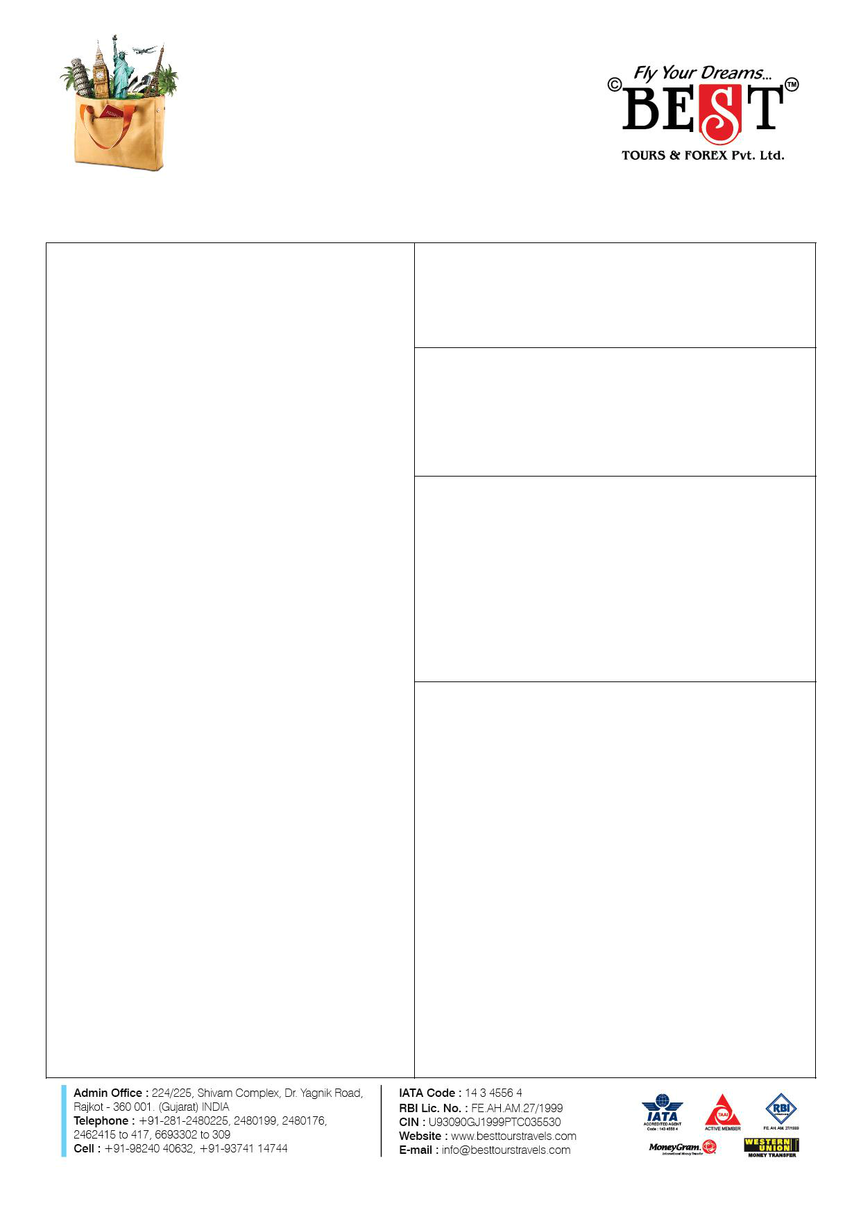Hong Kong on Arrival

- Macau on Arrival

- China Group visa (Extra cost of INR 7500 Payable if group visa not operative)

Hotels :

Hong Kong:

03 Night st ay in 4 * Hote l

Shenzhen:

02 Night in 4* Hote l

Macau:

02 Nights in the Venet ian M acau (5* )

- Service Of Experienced Tour Manager

- Overseas Mediclaim ( Upto age of 59 Years)

- 1 Bottle of Water

 | Flight Information:
 | NOTE: Best tours will not be responsible for change in flight schedules of the Airline.
AI 030  AI 316 | 27OCT  27OCT | AMD BOM |  |  | 0330 | 0440
AI 030  AI 316 | 27OCT  27OCT | BOM |  | HKG | 0835 | 1650
AI 311  AI 986 | 03NOV  04NOV |  | HKG | BOM | 1805  0530 | 2155  0645
AI 311  AI 986 |  |  | BOM AMD |  | 1805  0530 | 2155  0645

 |  | ADULT | ADULT | CHILD | CHILD | INFANT
 | CURRENCY
 | CURRENCY | (TWIN / | (SINGLE
 | PAYMENT IN INR | TRIPLE | (SINGLE | WITH BED | NO BED |   NO BED
TOUR COST | PAYMENT IN INR | TRIPLE | SHARING) | WITH BED | NO BED
TOUR COST |  | SHARING) | SHARING)
 | FULL PAYMENT | 1,15,000 | 1,72,500 | 1,03,500 | 92,000 | 49,999
 | PART PAYMENT | 1,20,000 | 1,80,000 | 1,08,000 | 96,000 | 49,999

5% GST EXTRA

DAYS | CANCELLATION CHARGES
Before 90 days | INR 25,000
61 – 90 days | 50%
46 – 60 days | 60%
31 – 45 days | 75%
0 – 30 days | 100% Non-Refundable

 | S u r c h a r g e s
D i w a l i | O c t 2 0 t o N o v 1 2 | I N R
D i w a l i | O c t 2 0 t o N o v 1 2 | 10,000/-
C h r i s t m a s | D e c 2 2 t o D e c 2 7 | I N R
C h r i s t m a s | D e c 2 2 t o D e c 2 7 | 10,000/-
N e w Y e a r | D e c 2 7 t o J a n 0 3 | I N R
N e w Y e a r | D e c 2 7 t o J a n 0 3 | 10,000/-

.

Terms & Conditions :

  - No name change once booked
  - Booking Amount will be non - refundable once booked
  - Minimum booking amount is 50% of the total , per person .

Note : In case of Visa rejection, the above - mentioned cancellation policy shall apply. Issuing of Visa or Refusal is solely in hands of Visa Consulate. BLISS TOURS & TRAVELS is not liable for any rejections.

Important Notes
- Tour Manager Service will only be provided if the Group Size is of 20 passengers. Below 20 Passengers group will have Driver cum guide.
- This is just a Quotation and not a confirmation. Rates may vary depending upon the availability.
- This is a group rate.
- For trade fares and any other surcharge date additional rate would be applicable.
- Any further increase in airfare due to increase in the fuel prices, change in government regulations, taxes, etc. charged by the airline will have to be borne by the passengers. BLISS TOURS & TRAVELS will not be held responsible for them. Above rates are subject to change without prior notice.
- International Hotel Check in time is 1500 Hrs and Check out Time is 1200 Hrs.
- Rates are based on Basic Category Rooms. Supplement cost will be applicable for any up gradation in room categories.
- Coach will be with you during your sightseeing only, in your free time we are not bound to serve you a vehicle. For further transportation needed during your free time has to be managed by you at your own cost.
- We will not be held responsible for any delay in Airline leading to misconnecting of onward flights.
- If any airline is delayed or cancelled, BLISS TOURS & TRAVELS is not responsible for any compensation for hotel, meals, sightseeing or any other claim.
- Final Tentative itinerary will be provided in pre-departure meeting for Group Departures while in case of FIT, It will be provided 02 Days prior to their Departure.
- If accommodation is not available in the identified / specific hotel for the particular package tour due to reason beyond our control, we shall make our best efforts to shift the clients to hotel maintaining / having more or less the same standard. No complaint or claim shall be made by the client in this respect.
- Any legal matters are subject to Jurisdiction of Rajkot Only.
- All Rights of final decisions is any case are reserved by BLISS TOURS & TRAVELS.

Contact - Siddharth Ahya - 9898236194

